BINF 701 – Systems Biology
Homework 1
October 4, 2018

Michaelis Menten Kinetics was developed to describe an enzyme-substrate reaction.

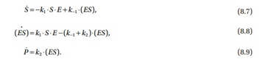
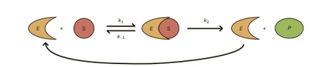
Solve the equation for Michaelis Menten Kinetics mathematically.

- Assume $(ES)$ is at steady state i.e. Eq 8.8 = 0
- Use the fact that enzyme is not consumed: $\left(E\right)+\left(ES\right)=E_{tot}$
- Solve the for $(ES)$ using 1) and 2). Remember to divide top and bottom by k₁
- Find the reaction rate by plugging in the expression for $\left(ES\right)$ into Eq. 8.9.
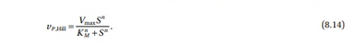
- You should get.

- Now solve equations 8.7, 8.8, and 8.9 numerically (on the computer). See if you can reproduce Figure 8.3 from the text.

- How does the forward reaction rate compare solved on the computer compare to that predicted by equation 8.14

